* 1. Introduction

**Purpose**

The purpose of the Airline Management System is to provide an advanced and user-friendly software solution that improves the management of airline operations and passenger services. This system is designed to enable and automate key functions, making it convenient for passengers to interact with the airline and for administrators to efficiently manage airline operations. The primary purposes of the system include:

**Efficient Booking:** The software authorizes passengers to book flights easily without the need for physical visits to airline counters, plus improving the booking process.

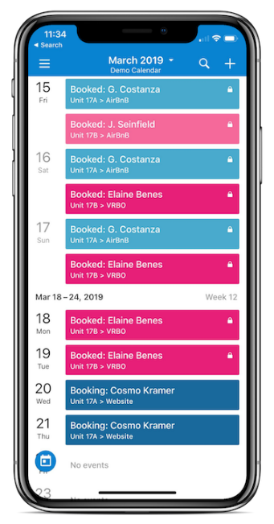

**Information Accessibility:** Passengers can readily access flight details, including schedules, destinations, and ticket pricing, which empowers them to make better decisions when planning their travels.

**Reservation Management:** Passengers can reserve seats and associated services through the system with less effort, providing a simplified and organized booking experience. The system also supports reservation modifications and cancellations for greater flexibility.

**Administrative Control:** Airline administrators can manage passenger bookings and maintain reservation statuses.

**Customizability:** The software is configurable, allowing airlines to modify it to their specific operational needs, branding, and policies.

**Accessibility and Availability:** The system is accessible to users 24/7 from any location with an internet connection, enabling passengers to interact with airline services.

**Scope**:

The Airline Management System encompasses a broad scope, covering the following aspects:

**User Management:** The system provides user accounts for both passengers and administrators. Passengers can create accounts, log in, and manage their reservations, while administrators have access to additional functionalities for control of the system.

**Flight Information:** The system maintains a complete database of flight information, including schedules, destinations, available seats, and ticket prices for both domestic and international flights.

**Booking and Reservations:** Passengers can search for flights, make reservations, and purchase tickets online. They can also cancel or modify reservations as needed.

**Payment Processing:** The system securely handles payment processing for ticket purchases, integrating with various payment gateways to ensure the safety of financial transactions.

**Seat Allocation:** The system assigns seats to passengers during the booking process and allows for seat selection based on availability.

**Notifications:** Passengers receive booking confirmations, flight status updates, and reminders via email or SMS.

**Reporting and Analytics:** The system generates reports that provide administrators with insights into booking trends, revenue, and passenger preferences.

**Administrative Controls:** Administrators can manage flight schedules, update reservation statuses, and monitor the performance of airline services.

**Customizability:** Airlines can tailor the system to align with their unique branding, policies, and operational procedures.

**Security:** The system implements robust security measures to safeguard passenger information, payment details, and system integrity.